ALL15800
ALL-2023-00147.R1
https://doi.org/10.1111/all.15800

Duygu Yazici, Eren Cagan, Ge Tan, Manru Li, Evan Do, Ozan C. Kucukkase, Abdurrahman Simsek, Muhammed Ali Kizmaz, Tugce Bozkurt, Tamer Aydin, Anja Heider, Beate Rückert, Marie-Charlotte Brüggen, Raja Dhir, Liam O'Mahony, Mubeccel Akdis, Kari C. Nadeau, Ferah Budak, Cezmi A. Akdis, Ismail Ogulur
Disrupted epithelial permeability as a predictor of severe COVID-19 development
- This study provides evidence that epithelial barrier function is compromised in severe COVID-19, which is also in line with the epithelial barrier theory.
- We identified predictive biomarkers to powerfully discriminate severe COVID-19 cases from mild cases and healthy controls at the time of admission.
- We demonstrated certain protein biomarkers with disease progression from moderate to severe COVID-19 and death.

Abbreviations: AREG, amphiregulin; AUC, area under the curve; AXIN1, axis inhibition protein 1; CKAP4, cytoskeleton-associated protein 4; CLEC4C, C-type lectin domain family 4 member C; CLEC7A, C-type lectin domain family 7 member A; COVID-19, coronavirus disease 2019; CXCL, C-X-C motif chemokine; CXADR, coxsackievirus and adenovirus receptor; DNA, deoxyribonucleic acid; HGF, hepatocyte growth factor; ITGB6, integrin beta-6; KRT19, keratin, type 1 cytoskeletal 19; LAMP3, lysosome-associated membrane glycoprotein 3; TRANCE, tumor necrosis factor ligand superfamily 11; ZFP, zonulin family peptides; 4E-BP1, eukaryotic initiation factor 4E-binding protein 1

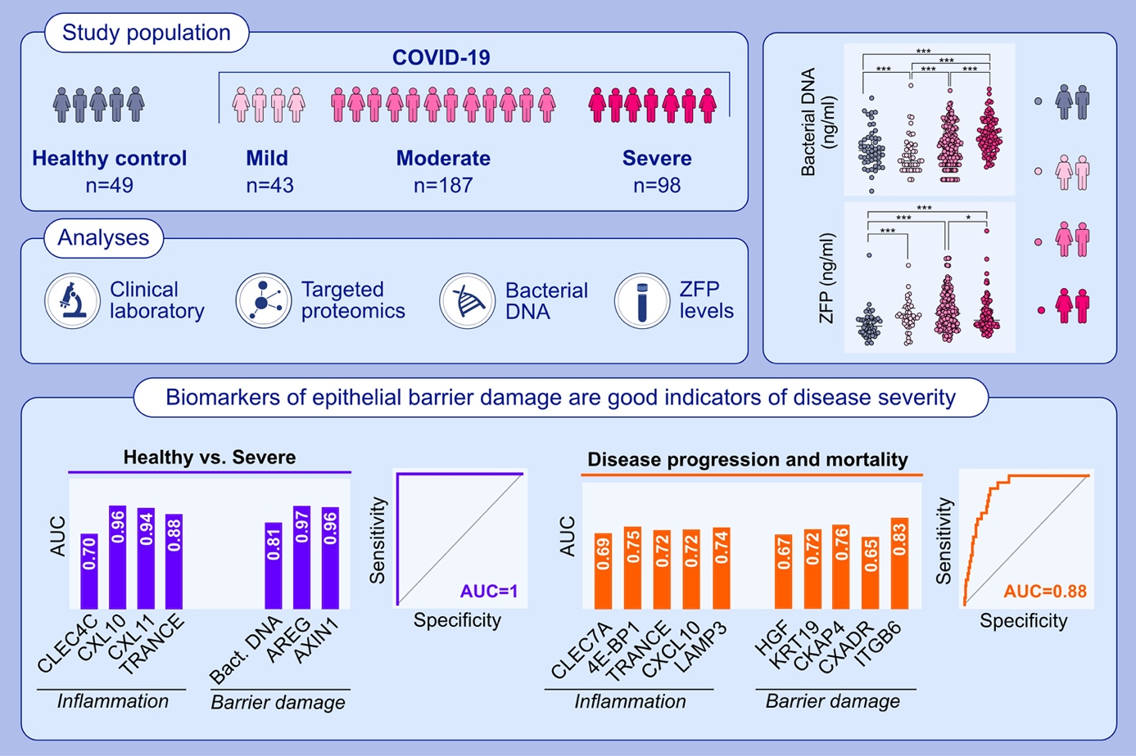
bacterial DNA, biomarker, COVID-19, epithelial barrier, zonulin family peptides
ALL15771
ALL-2023-00199.R1
https://doi.org/10.1111/all.15771

Brian S. Schwartz, Jonathan S. Pollak, Karen Bandeen-Roche, Annemarie G. Hirsch, Ashton E. Lehmann, Robert C. Kern, Bruce K. Tan, Atsushi Kato, Robert P. Schleimer, Anju T. Peters
Sinus inflammation and chronic rhinosinusitis are associated with a diagnosis
of new onset asthma in the following year

- CRS and asthma commonly co-occur, but no studies have leveraged the very large sample sizes needed to address whether preexisting CRS is associated with new onset asthma over time.
- In a longitudinal study of over 900,000 persons from 2008–2019, prevalent CRS (identified with sinus CT scan or diagnoses) was associated with 1.5-2.2-fold increased risk of the diagnosis of new onset asthma in the following year.
- The findings may have implications for the prevention of adult-onset asthma.

Abbreviations: CRS, chronic rhinosinusitis; CT, computerized tomography.

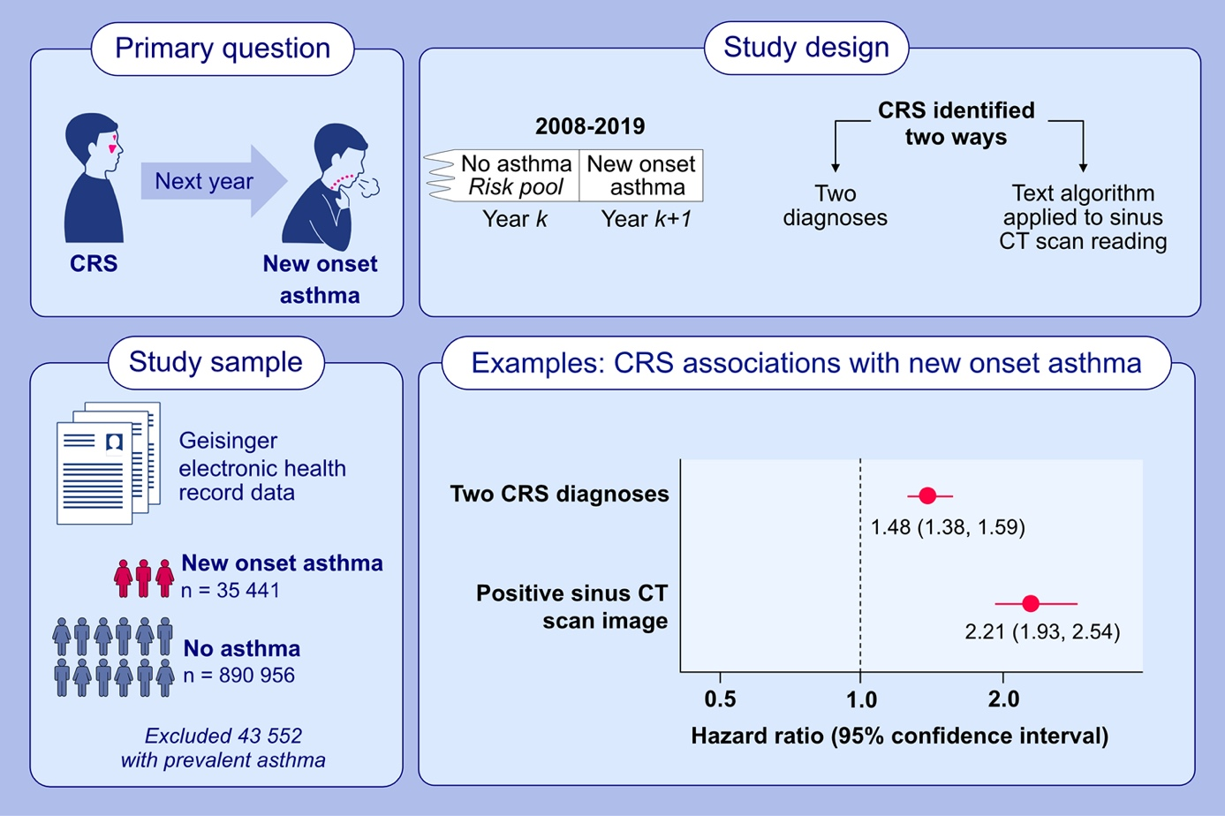

asthma etiology, epidemiology, rhinosinusitis, risk factors

ALL15772
ALL-2023-00106.R1
https://doi.org/10.1111/all.15772

Eugenio De Corso, Ernesto Pasquini, Matteo Trimarchi, Ignazio La Mantia, Fabio Pagella, Giancarlo Ottaviano, Massimiliano Garzaro, Carlotta Pipolo, Sara Torretta, Veronica Seccia, Elena Cantone, Andrea Ciofalo, Daniela Lucidi, Gian Luca Fadda, Pia Clara Pafundi, Stefano Settimi, Claudio Montuori, Francesca Anastasi, Giulio Pagliuca, Angelo Ghidini, Carlo Cavaliere, Marianna Maffei, Francesco Bussu, Stefania Gallo, Frank Rikki Mauritz Canevari, Gaetano Paludetti, Jacopo Galli, Dupireal Italian Study Group

Dupilumab in the treatment of severe uncontrolled CRSwNP:
a multicentric observational phase 4 real-life study (DUPIREAL)

- This study assessed the effectiveness and safety of dupilumab in severe uncontrolled CRSwNP.
- In the first 12-months, dupilumab significantly decreased NPS and SNOT-22 and improved smell function; an excellent-moderate response was observed in 96.9% of patients.
- At study end, only 6 patients had discontinued dupilumab due to a major adverse event.

Abbreviations: CRSwNP, chronic rhinosinusitis with nasal polyps; NPS, nasal polyp score; SNOT-22, sino-nasal outcomes test-22

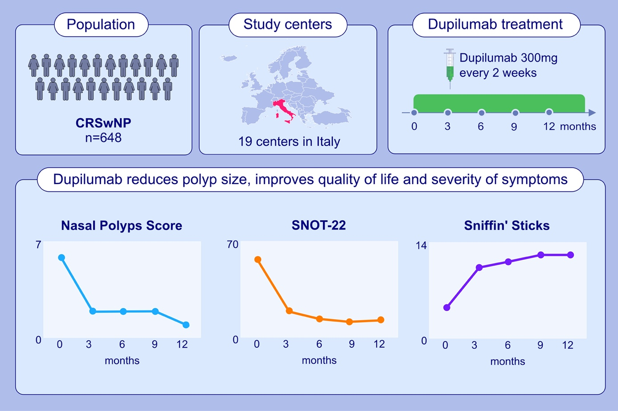

asthma, biologics, chronic rhinosinusitis with nasal polyps, dupilumab, smell

ALL15796
ALL-2023-00203.R1
https://doi.org/10.1111/all.15796

Rik Johannes Leonardus van der Lans, Josje Janna Otten, Gwijde Flavius Jacobus Petrus Maria Adriaensen, Dinand Rienk Hoven, Linda Berendina Benoist, Wytske Johanna Fokkens, Sietze Reitsma

Two-year results of tapered dupilumab for CRSwNP demonstrates enduring efficacy established in the first 6 months

- Two-year results of tapered dupilumab for severe chronic rhinosinusitis with nasal polyps (CRSwNP) from a real-life prospective observational cohort (n=228, tertiary referral center).
- Marked improvements show for disease specific quality of life, nasal polyp score, asthma control and olfaction, principally established within 24 weeks.
- Stepwise tapering dupilumab conditional to therapeutic effect is feasible up to 300mg/8 weeks.

Abbreviations: ACT, asthma control test; CRSwNP, chronic rhinosinusitis with nasal polyps; NPS, bilateral nasal polyp score; SNOT-22, 22-item sinonasal outcome test; SSIT-22, Sniffin’Sticks-12 identification test

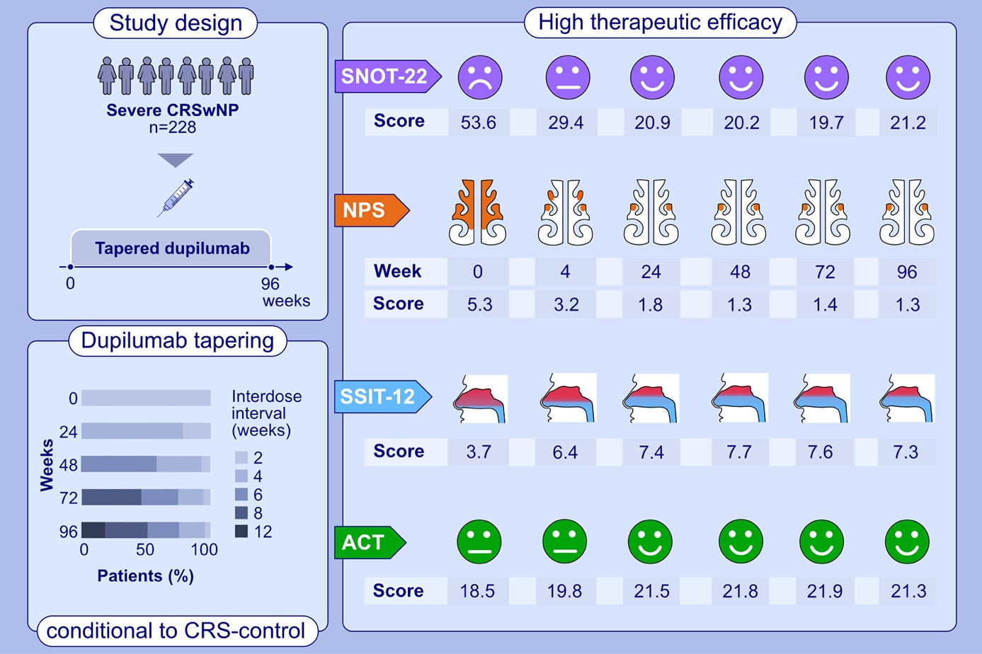

biological therapy, CRSwNP, dupilumab, long term, nasal polyps, observational study, sinusitis, treatment outcome

ALL15837
ALL-2022-00854.R2
https://doi.org/10.1111/all.15837

Marcus M. Soliai, Atsushi Kato, Katherine A. Naughton, James E. Norton, Aiko I. Klinger, Robert C. Kern, Bruce K. Tan, Dan L. Nicolae, Robert P. Schleimer, Carole Ober, Jayant M. Pinto

Epigenetic responses to rhinovirus exposure in airway epithelial cells
are correlated with key transcriptional pathways in chronic rhinosinusitis

- This study identified differential gene expression and epigenetic profiles of the airway epithelium between CRSwNP cases and non-CRS controls in an in vitro cell model.
- Interaction effects indicated that the epigenetic response to RV infection significantly differed between cases and controls. Distinct co-regulated gene expression and DNAm modules were specific to CRSwNP and to RV infection.
- These data suggest that intrinsic epigenetic features in the airway epithelium of CRSwNP influence the response to RV infection and increase susceptibility to CRS.

Abbreviations: CRSwNP, chronic rhinosinusitis with nasal polyps; DNAm, DNA methylation; DTC, dynamic tree cut; MD, merged dynamic; RNA-Seq, RNA sequencing; RV, rhinovirus

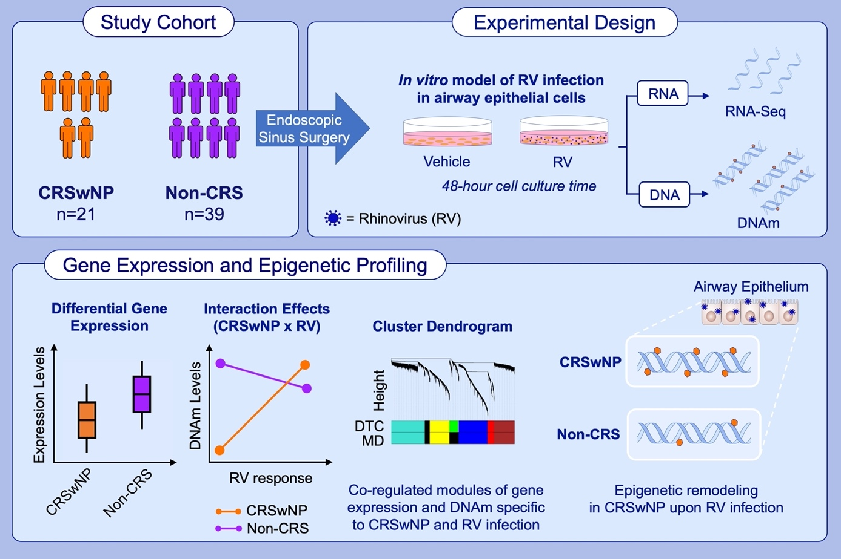

airway epithelium, chronic rhinosinusitis, DNA methylation, gene expression, nasal polyposis

ALL15844
ALL-2023-00346.R1
https://doi.org/10.1111/all.15844

Fabio S. Ryser, Ayla Yalamanoglu, Alan Valaperti, Catrin Brühlmann, Tina Mauthe, Stephan Traidl, Michael B. Soyka, Urs C. Steiner

Dupilumab-induced eosinophilia in patients with Diffuse Type 2 Chronic Rhinosinusitis

- Transient blood eosinophilia seems to have no clinical impact in patients with type 2 CRS treated with dupilumab.
- High IL-4 levels at baseline induce dysregulation of migration, chemotaxis, and homing of eosinophils by decreased CXCR4 on eosinophils and VCAM-1.
- CXCR4 might be a useful marker to predict blood eosinophilia in patients with type 2 CRS under dupilumab.

Abbreviations: CRS, chronic rhinosinusitis; CXCR4, CXC chemokine receptor 4 (stromal cell-derived factor 1 receptor); IL-4, interleukin 4; SNOT-22, sino-nasal outcome test 22 questionnaire; TNPS, total nasal polyp score; VCAM-1, vascular adhesion molecule 1

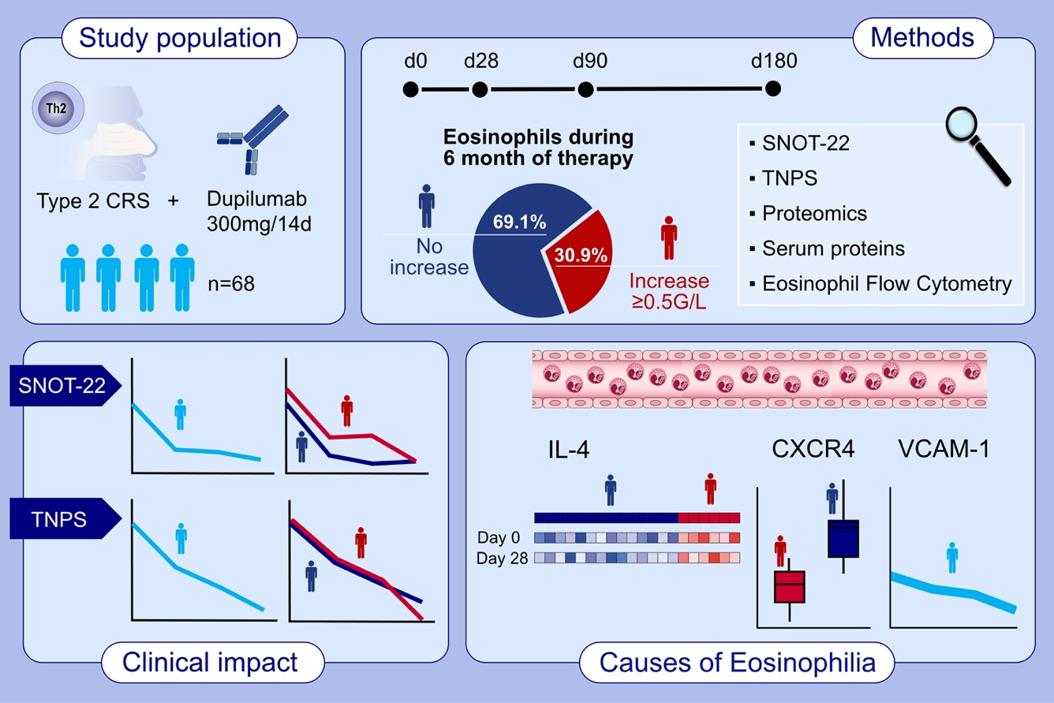
diffuse type 2 chronic rhinosinusitis, dupilumab, eosinophilia, Interleukin-4, VCAM-1

ALL15806
ALL-2023-00241.R2
https://doi.org/10.1111/all.15806

Prem Prashant Chaudhary, Ian A. Myles, Jordan Zeldin, Shareef Dabdoub, Varsha Deopujari, Rajiv Baveja, Robin Baker, Sarah Bengtson, Ashleigh Sutton, Shira Levy, Suchitra K. Hourigan

Shotgun metagenomic sequencing on skin microbiome indicates dysbiosis exists
prior to the onset of atopic dermatitis

- Using a larger cohort, this study reproduces the prior findings indicating that the dysbiosis associated with AD predates diagnosis.
- Expansion to use of shotgun metagenomics identified Prevotella, Candida, and lipid metabolism of Proteobacteria as additional biomarkers of subsequent onset of AD.
- This work may foster primary prevention by using the microbiome signature from the first week of life to identify high risk newborn.

Abbreviations: AD, atopic dermatitis; BolA1, BolA Family Member 1; FRAT2, frequently rearranged in advanced T-cell lymphomas 2; XagA, Proteobacteria quorum sensing and biofilm regulator

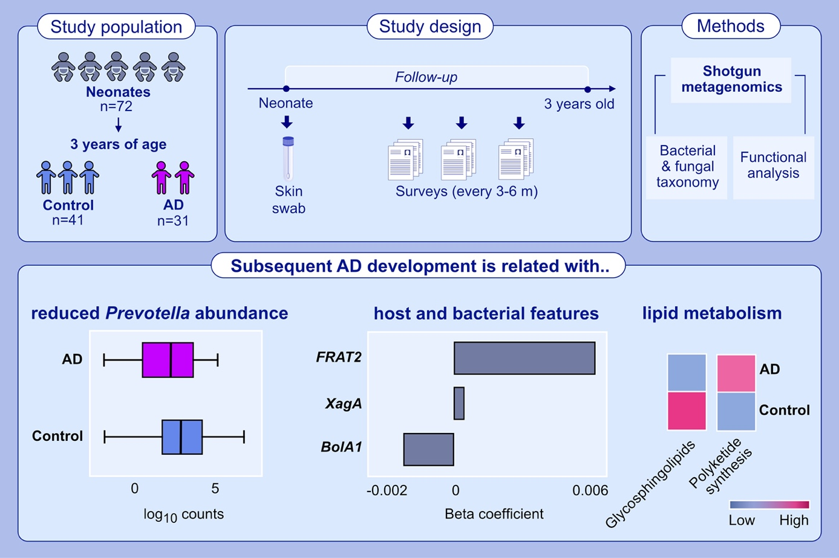
atopic dermatitis, dysbiosis, eczema, Malassezia, microbiome, Staphylococcus

ALL15779
ALL-2023-00006.R3
https://doi.org/10.1111/all.15779

Francisca Molina-Jiménez, Lola Ugalde-Triviño, Laura Arias-González, Carlos Relaño-Rupérez, Sergio Casabona, María Teresa Pérez-Fernández, Verónica Martín-Domínguez, Jennifer Fernández-Pacheco, Emilio José Laserna-Mendieta, Patricia Muñoz-Hernández, Ángel Arias-Arias, Ainara Cano, Javier Muñoz, Alfredo J. Lucendo, Cecilio Santander, Pedro Majano

Proteomic Analysis Reveals Key Features of Eosinophilic Esophagitis Pathophysiology

- This study employed unbiased proteomics approach and RNAseq to investigate pathophysiological changes in esophageal epithelium.
- Protein expression positively correlated with EDP and Eso-EoE, and corresponded with the most abundant proteins of the human esophageal proteome. Pathway analysis in EoE showed alterations in immune and inflammatory responses, epithelial differentiation, cornification and keratinization.
- A set of differentially accumulated proteins, including eosinophil-related and secreted proteins, was not detected at mRNA level.

Abbreviations: EDP, EoE diagnostic panel; EoE, eosinophilic esophagitis; EPX, eosinophil peroxidase; Eos, eosinophil; EREFS, EoE endoscopic reference score; Eso-EoE, esophageal biopsy from EoE patient; hpf, high-power field; HSS, histologic scoring system; PRG3, proteoglycan 3; RNASE, ribonuclease A family member; RNAseq, RNA sequencing; SERPINC1, serpin family C member 1

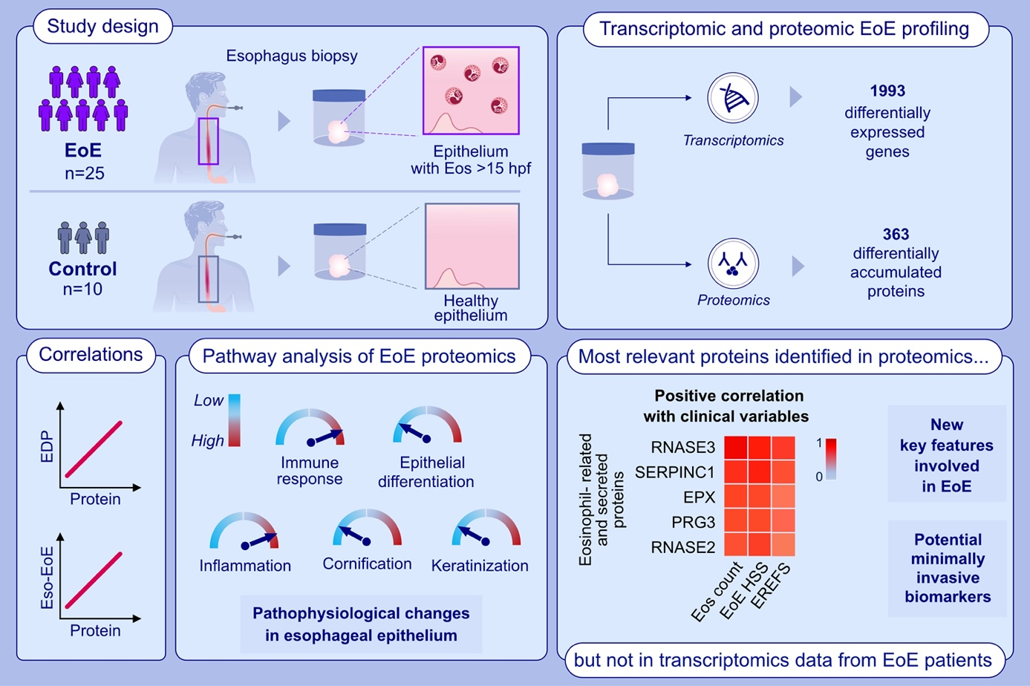
basic mechanisms, eosinophilic esophagitis, epithelium, proteomic
ALL15610
ALL-2022-00743.R3
https://doi.org/10.1111/all.15610

Jose A. Céspedes, Rubén Fernández-Santamaría, Adriana Ariza, Gador Bogas, Inmaculada Doña, Carmen Rondón, María Salas, Marina Labella, Cecilia Frecha, Cristobalina Mayorga, María J. Torres, Tahia D. Fernández

Diagnosis of immediate reactions to amoxicillin: Comparison of basophil activation markers CD63 and CD203c in a prospective study

- Patients suffering from an immediate reaction after AX or AX-CLV intake have been prospectively recruited. BAT with CD63 and CD203c was performed.
- BAT using CD203c in IRs to AX has shown high specificity and good confirmatory power.
- BAT to AX with CD203c as first step in the diagnostic algorithm could avoid the performance of in vivo tests in some patients.

Abbreviations: AX, amoxicillin; BAT, basophil activation test; CLV, clavulanic acid;
IRs, immediate reactions

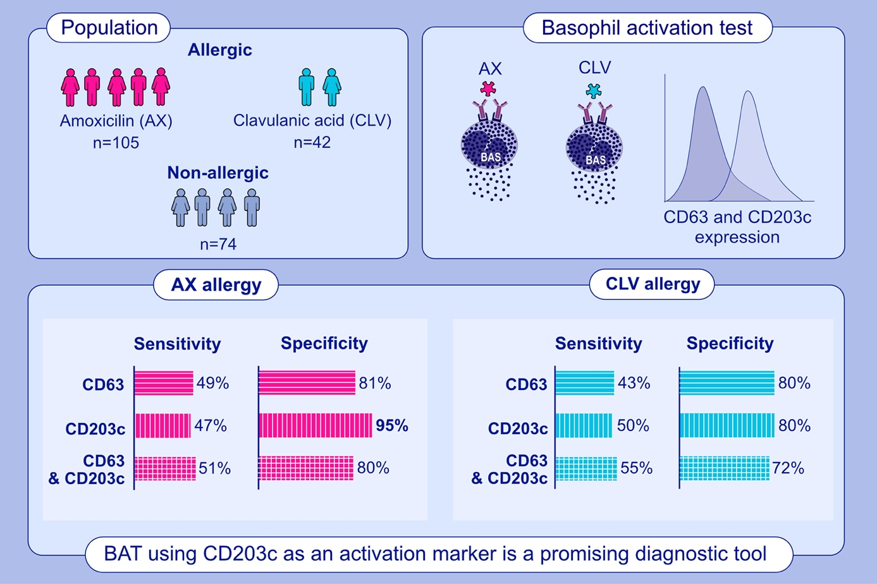

amoxicillin, basophils, clavulanic acid, drug allergy, immediate reactions

ALL15788
ALL-2023-00167.R1
https://doi.org/10.1111/all.15788

P. J. de Kam, S. Zielen, J. A. Bernstein, U. Berger, M. Berger, M. Cuevas, D. Cypcar, A. Fuhr-Horst, W. A. Greisner, M. Jandl, S. Laßmann, M. Worm, J. Matz, E. Sher, C. Smith, G. C. Steven, R. Mösges, M. H. Shamji, L. DuBuske, F. Borghese, K. Oluwayi, T. Zwingers, M. Seybold, O. Armfield, M. D. Heath, S. J. Hewings, M. F. Kramer, M. A. Skinner

Short-course subcutaneous treatment with PQ Grass strongly improves symptom
and medication scores in grass allergy

- PQ Grass or placebo were administered in a double-blind fashion to 119 adult subjects with moderate-to-severe seasonal grass allergy.
- The primary CSMS showed a clinically relevant and statistically significant improvement after PQ Grass compared to placebo for both regimens: 39.5% [p=0.0112; 80% CI: -54.7% to -24.4%] and 33.1% [p=0.0325; 80% CI: -48.8% to -17.4%] for the extended and conventional regimen, respectively.
- An increase in IgG4 was shown for both extended and conventional regimen (p<0.01). Both regimens were well-tolerated. Based on enhanced efficacy profile extended regime will be progressed to the pivotal Phase III trial.

Abbreviations: CI, confidence interval; CSMS, combined symptom and medication score;
PQ Grass, a modified grass allergen subcutaneous immunotherapy product with MicroCrystalline Tyrosine and Monophosphoryl Lipid-A as an adjuvant system

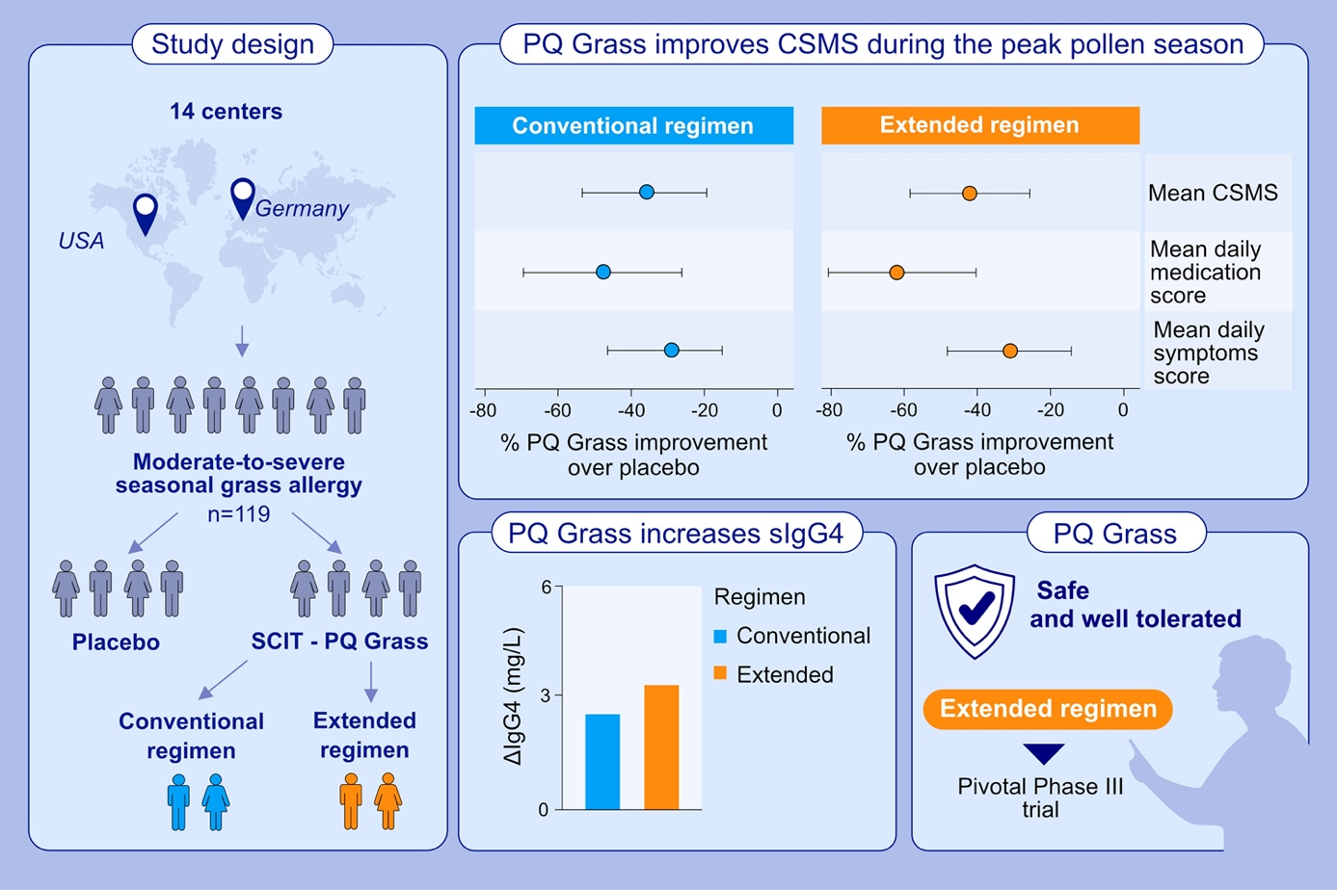
allergic rhinoconjunctivitis, grass pollen allergy, short-course treatment, subcutaneous immunotherapy

