https://doi.org/10.1111/all.16060

Transcriptomic evaluation of skin tape-strips in children with allergic asthma uncovers epidermal barrier dysfunction and asthma-associated biomarkers abnormalities

- Using RNA-seq profiling, we characterized the normal-appearing skin of children with moderate allergic asthma and severe allergic asthma in comparison to healthy controls.
- Tape-strips of normal appearing skin from children with moderate allergic asthma and severe allergic asthma depict dysregulation of genes associated with epithelial barrier, lung extracellular milieu and correlate with asthma severity.
- A two-gene classifier, TSSC4 and FAM212B, differentiate asthmatic children from HCs with 100% accuracy.

Abbreviations: AUC, area under the curve; CDH, cadherin; COX6B1, cytochrome c oxidase 6B1; EGFR, epidermal growth factor receptor; FAM212B, family with sequence similarity 212, member B; FeNO, fractional exhaled nitric oxide; FEV1; forced expiratory volume in 1 second; FLG, filaggrin; GPCRs, G protein-coupled receptors; IFN, interferon; IOS, impulse oscillometry; IOS-R5-20, a measure of peripheral airway resistance; KRT, keratin; RNA-seq, RNA sequencing; TAS1R3; taste 1 receptor member 3; TGF, transforming growth factor; Th, T helper; TSSC4, tumor suppressing subtransferable candidate 4.

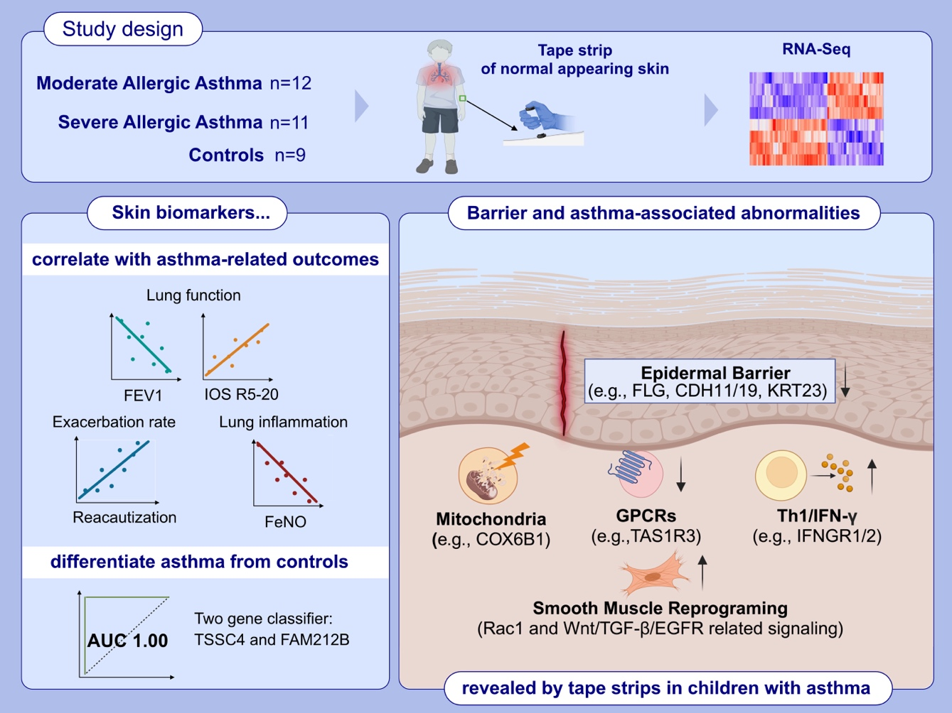

airway remodeling, allergic asthma, asthma-related outcomes, atopic march, epithelial barrier, tape-strips, transcriptomic biomarkers

https://doi.org/10.1111/all.16062

Epidermal barrier impairment predisposes for excessive growth
of the allergy-associated yeast Malassezia on murine skin

- The abundant commensal yeast Malassezia overgrows in AD-like skin.
- Using four different experimental models of AD, we show that Malassezia acquires enhanced fitness in the barrier-impaired and metabolically dysregulated skin.
- The lipid-dependent yeast adapts to the AD-like skin for enhanced nutrient assimilation.
Abbreviations: AD, atopic dermatitis; WT, wildtype.

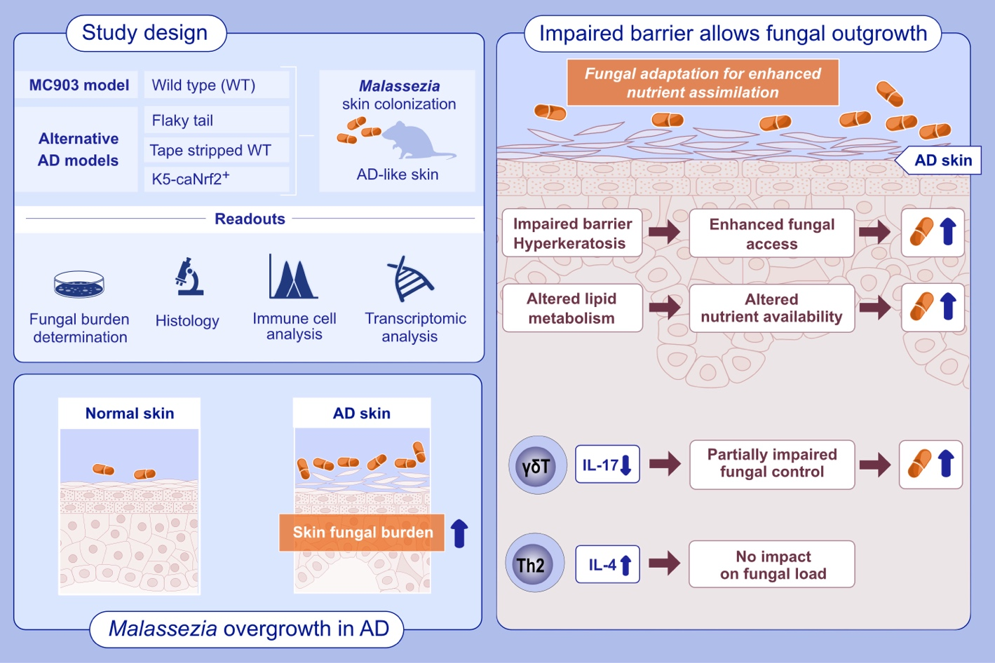

atopic dermatitis, epidermal barrier impairment, fungal adaptation, Malassezia, skin immunity

https://doi.org/10.1111/all.16086

RNA-sequencing of paired tape-strips and skin biopsies in atopic dermatitis reveals key differences

- Tape strips yielded a lower yield of RNA and fewer sequences mapping to known genes than biopsies.
- Paired sampling from the same skin (AD or no AD) identified differential detection of thousands of genes between tape strips and biopsies.
- Tape strips performed better than biopsies for identifying differentially expressed genes in AD.
Abbreviation: AD, atopic dermatitis

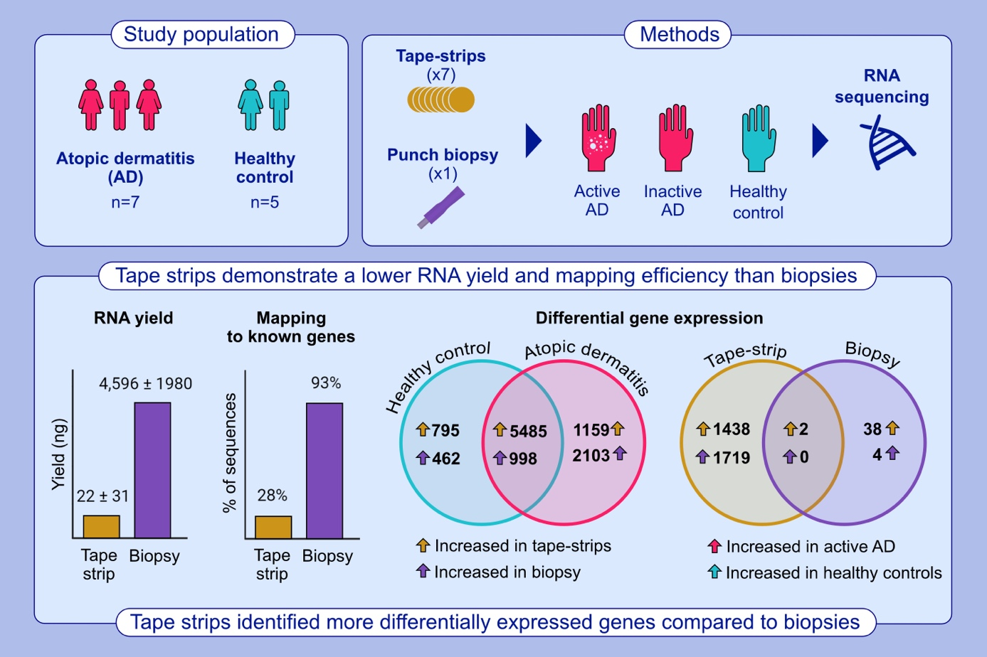

atopic dermatitis, biopsies, inflammation, RNA sequencing, tape-strips

https://doi.org/10.1111/all.16108

Targeting IL-13 with tralokinumab normalizes type 2 inflammation
in atopic dermatitis both early and at 2 years

- This study evaluated early and 2-year impacts of IL-13 neutralization on skin
and serum biomarkers following tralokinumab treatment in adults with moderate-to- severe AD.
- Specific targeting of IL-13 with tralokinumab improved epidermal pathology
and normalized expression of key biomarkers in serum and lesional skin in patients with moderate-to-severe AD.
- These data further support the central role of IL-13 in driving AD pathology
and highlight that inhibition of IL-13 alone is sufficient for normalizing the molecular phenotype of AD.

Abbreviations: AD, atopic dermatitis; CCL-17, CC-motif chemokine ligand 17; IFN-γ, interferon γ; IgE, immunoglobulin E; IL, interleukin; ILC2, group 2 innate lymphoid cells; Th, T helper cell; TNF-α; tumor necrosis factor α; TSLP, thymic stromal lymphopoietin.

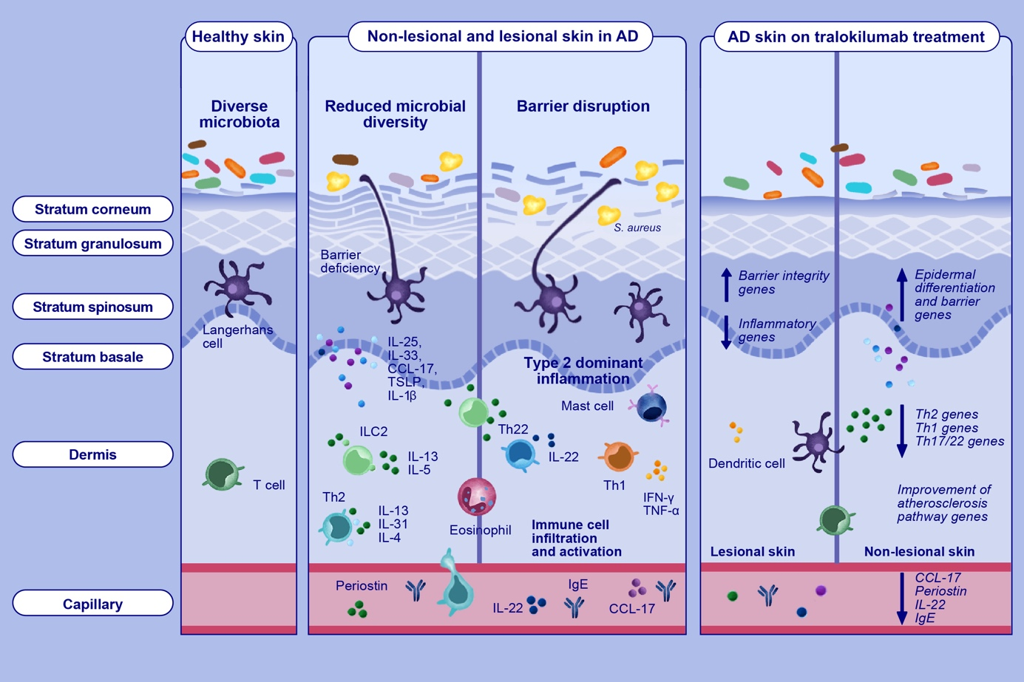

atopic dermatitis, biomarkers, gene expression, tralokinumab, type 2 inflammation

https://doi.org/10.1111/all.16125

Inhibition of RNase 7 by RNase inhibitor promotes inflammation and Staphylococcus aureus growth: Implications for atopic dermatitis

- The lesional skin of AD patients releases increased amounts of RNase inhibitor (RI).
- Host RI binds to RNase7 and blocks its ribonuclease and antimicrobial activity. This inactivation has an enhancing effect on the RNA-mediated pro-inflammatory response and S. aureus growth.
- These new data reveal a previously unknown role of the RNase7 - RI interaction in AD.

Abbreviations: AD, atopic dermatitis; CFU, colony forming units; RNA, ribonucleic acid; RI, RNase inhibitor; S. aureus, Staphylococcus aureus; siRNA, small interfering RNA.

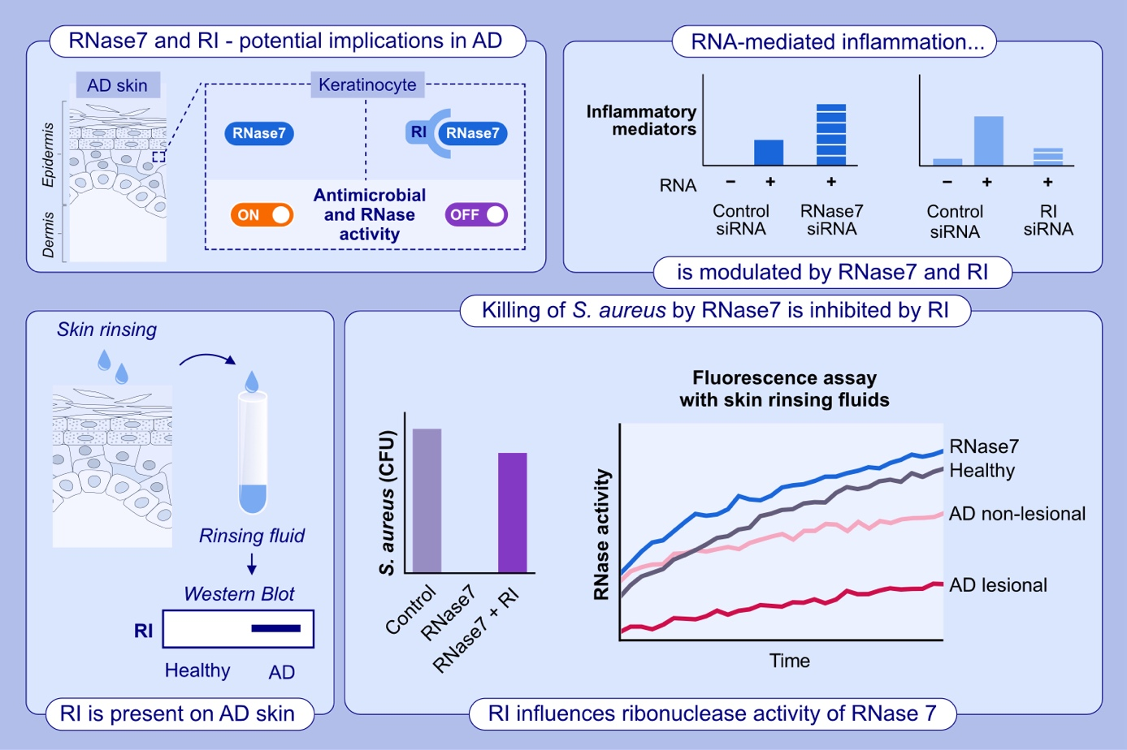

antimicrobial protein, atopic dermatitis, keratinocytes, RNase 7, RNase inhibitor, skin defense, skin inflammation

https://doi.org/10.1111/all.16121

Mapping the immune cell landscape of severe atopic dermatitis
by single-cell RNAseq

- We analyzed blood samples from 12 patients with severe atopic dermatitis (EASI>21) using single-cell RNA sequencing. Additionally, we validated our findings with skin single-cell spatial sequencing and flow cytometry.
- Our findings revealed a strong correlation between disease severity and the expansion of ILC2s and ISG-Monocytes. Conversely, the number of NK cells was decreased in the patients, and the expression of cytotoxic/effector molecules in NK cells was negatively correlated with disease severity.
- Moreover, our study identified severe AD-dominant Th2-DCs that exhibited features of Th2-priming DC signals and interacted with Th2 cells residing in AD lesional skin.

Abbreviations: AD, atopic dermatitis; DC, dendritic cell; DE_junction, dermis epidermis junction; EASI, eczema area and severity index; IL, interleukin; ILC2, group 2 innate lymphoid cell; IRF4, interferon regulatory factor 4; ISG, interferon-stimulated genes; MO, monocyte; NK, natural killer cell; STAT6, signal transducer and activator of transcription 6; TNFR, tumor necrosis factor receptor.

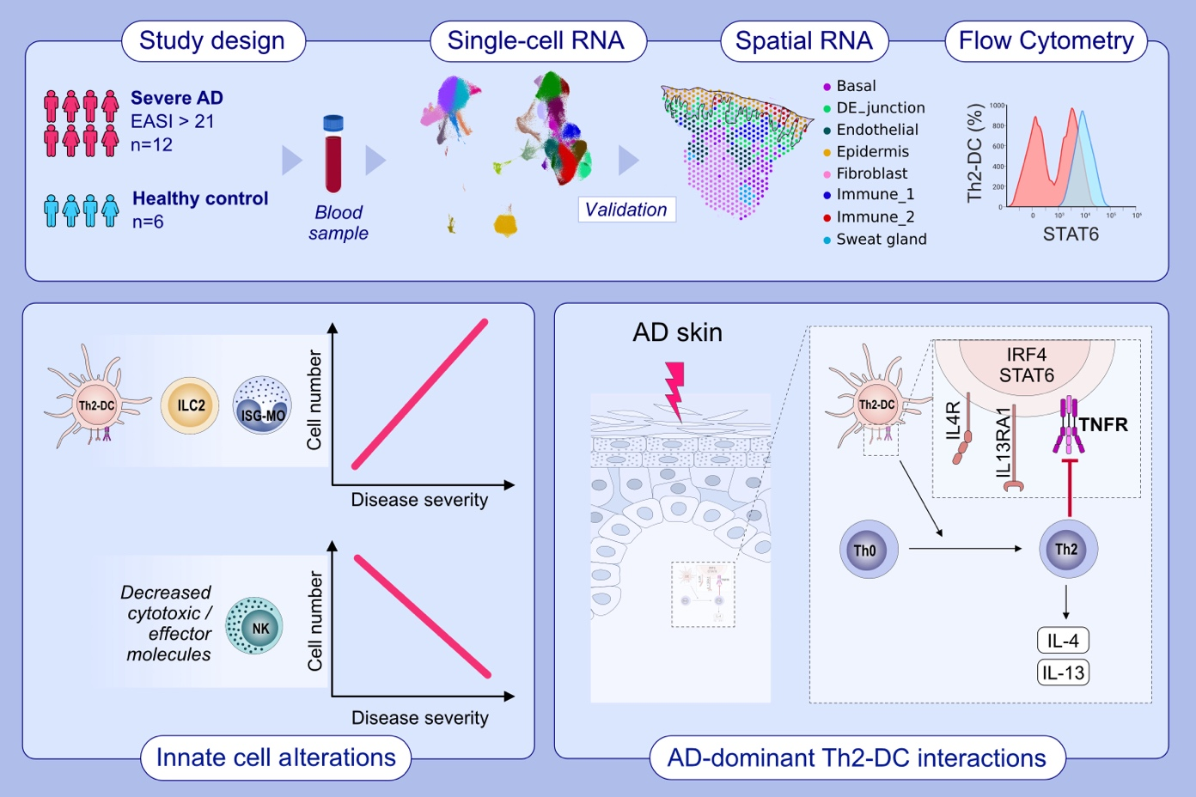

atopic dermatitis, chronic inflammatory disease, innate immunity, severe atopic dermatitis, single-cell RNA-Seq

